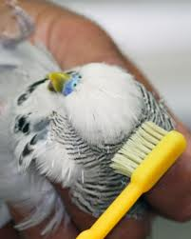
Tooth brush to help remove the waxy layer around new feathers to enable to open faster.
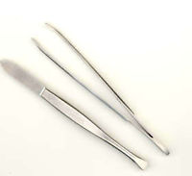
Tweezers for despotting

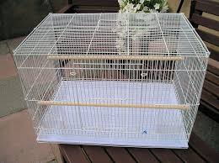
Stock cage

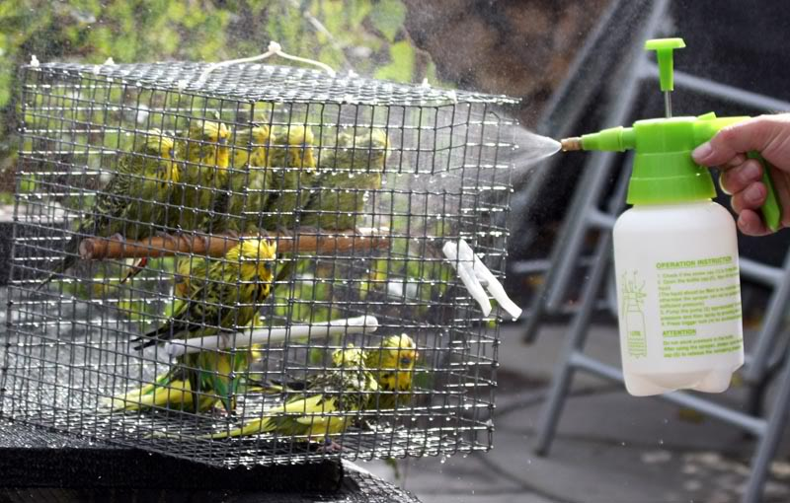
Cage that can be moved outside to spray the birds. Spray bottle that can produce a fine mist.

